Papers written by
Australian Maths Software

REVISION 1
2016

SEMESTER 2

MATHEMATICS
APPLICATIONS
Units 1 & 2

SOLUTIONS

SECTION 1 – Calculator-free
Question 1 (8 marks)
(a) (i) “Place of birth” is nominal
as there can be a number of places of birth, but there is no intrinsic ranking as in ordinal numbers.
(ii)
9
8
7
6
5
4
3
2
1

(ii)
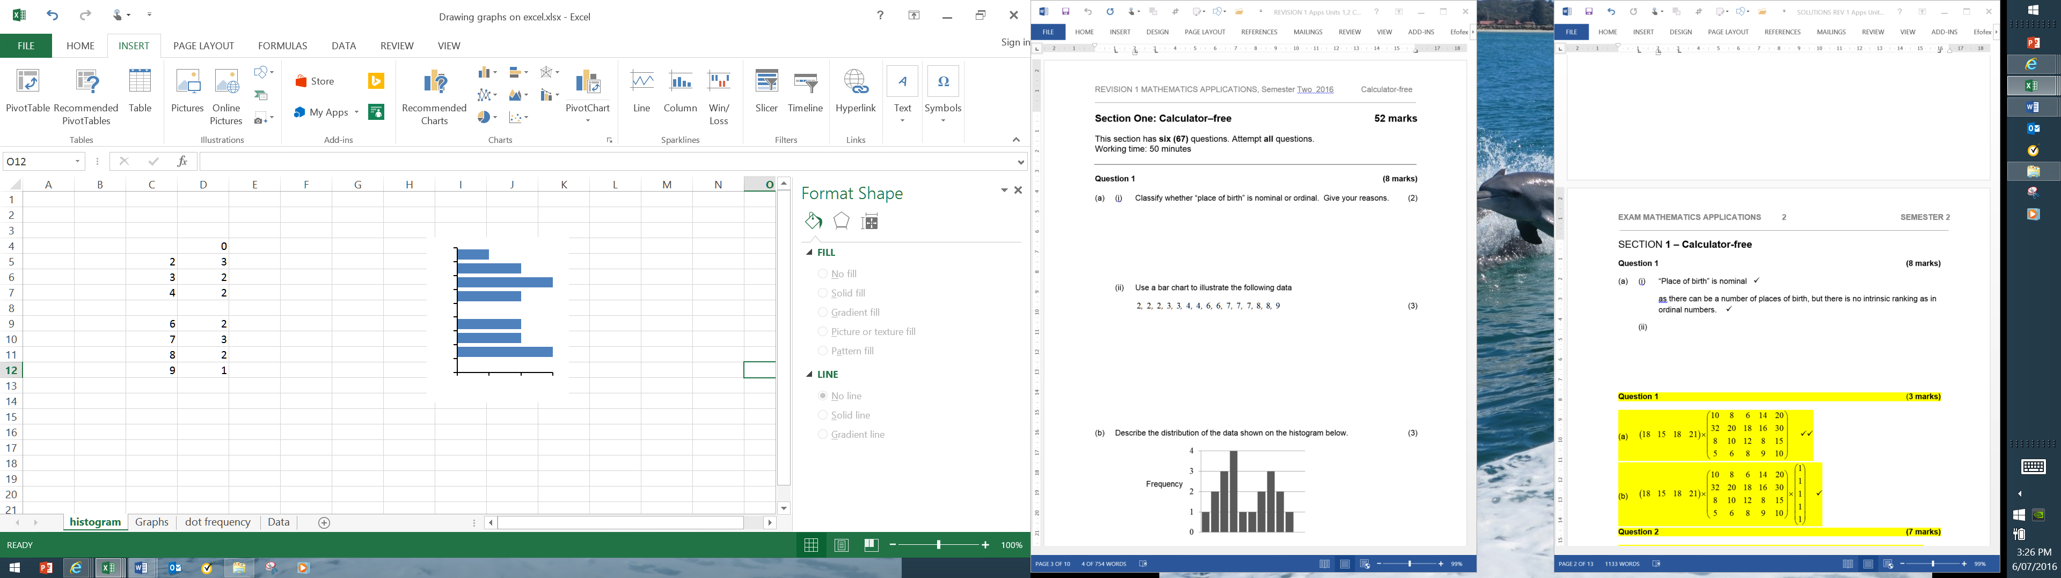

1 | 2 | 3

(b) The distribution is bi-modal. Scores are clustered around two different scores. There
seems to be no outlier. Most of the scores are high or low with not too many in the middle.

Question 2 (7 marks)
(a) These two matrices cannot be added as they are a different size.
(b)
(c)
(d)

Question 3 (9 marks)
(a) (i)
(ii)
(b)
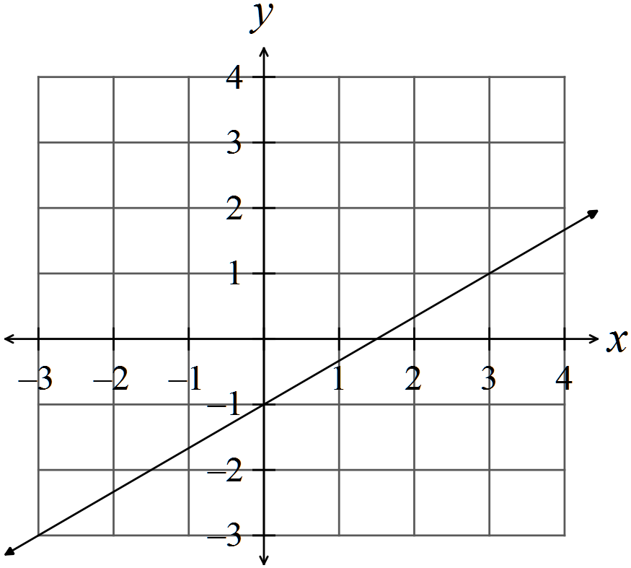

(c)
(d)
Question 4 (12 marks)
(a)
(b)
(c)
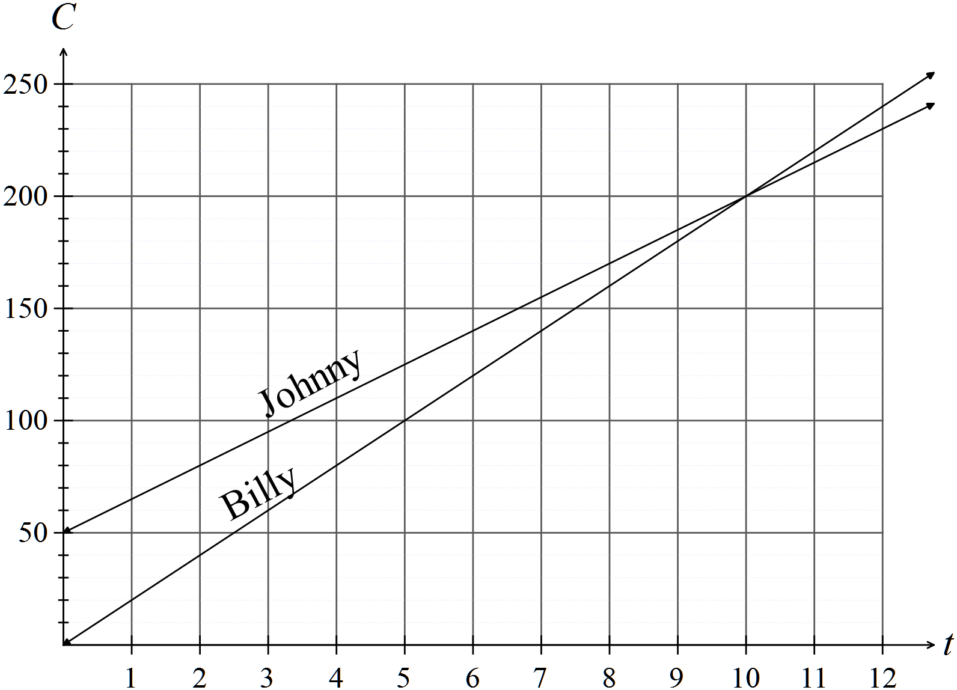

(d)
Billy s the cheaper gardener for 7 hours work.
(e) Costs are the same for 10 hours work.

Question 5 (10 marks)
(a) Range = 7 – 0 = 7 Median = 2 IQR = 5.5 – 1 = 4.5
(b) Any two of
The mean, standard deviation, variance, mode

(c) Set 1 has a range of 7 whereas set 2 has a range of 5. Set 2 may have outliers.
Set 1 has an IQR of 4.5 whereas set 2 has an IQR of 2, so the middle 50% of set 2 is more tightly clustered.
Set 1 has 25% of scores between 1 and 2 and the next 25% of the scores between 2 and 5.5, The median of set 1 is at 2, so the data is skewed to the right whereas the median of set 2 is in the middle of the middle 50% of scores which means that it is possible for set 2 to have low outliers.
Question 6 (6 marks)
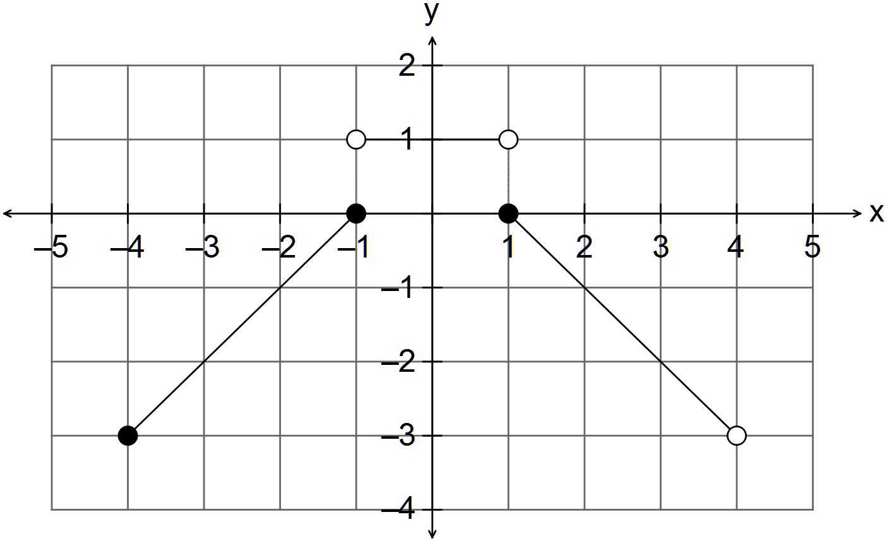

END OF SECTION ONE

SECTION 2 – Calculator-assumed
Question 7 (7 marks)

(a)

(b)

Question 8 (8 marks)
(a) (i)
(ii) 9, 10, 11
(iii)
(b)
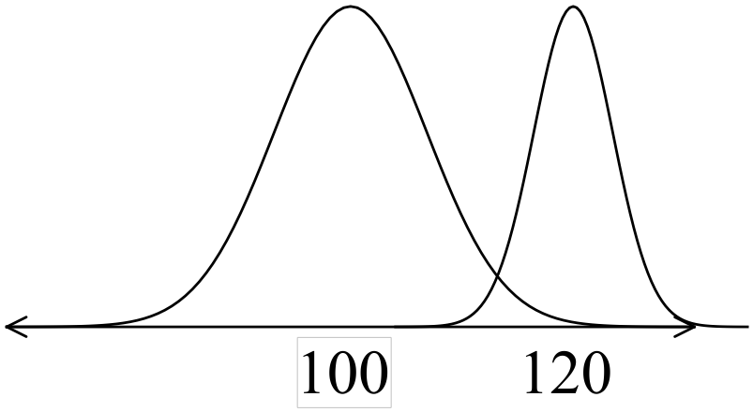

Question 9 (5 marks)
(a)

(b)
i.e. $2222

Question 10 (9 marks)
(a) Jim $20 x 30 + 2 x 1.5 x $20 = $600 + $60 = $660

James $16 x 40 = $640
Jim earns $20 more

(b) (i) Rent $350 Phone $40
Car $250 Electricity $90
Food $120 Gas $60
Entertainment $40 $190
$760
Therefore total per week is $803.85

(ii)

Question 11 (7 marks)
(a) Coles

Woolworths
Woolworths is the cheaper buy.

(d) (i) $130x0.80 = $104

(ii) Profit = $14
Profit % =

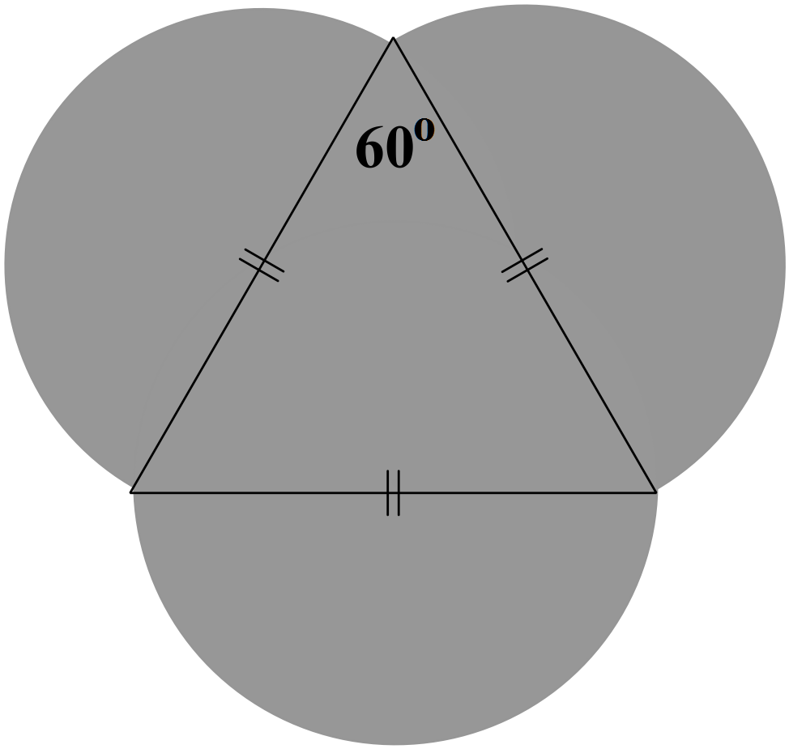Question 12 (16 marks)
(a) Area = area of triangle + 1.5 area of circle

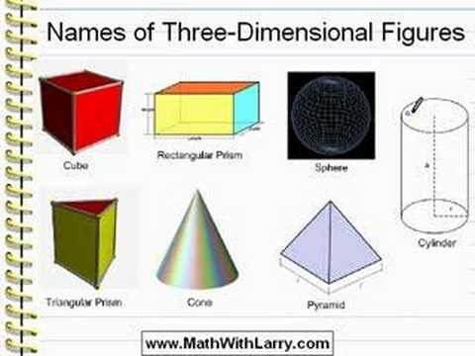
(b)
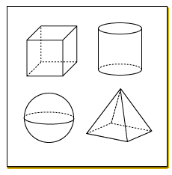

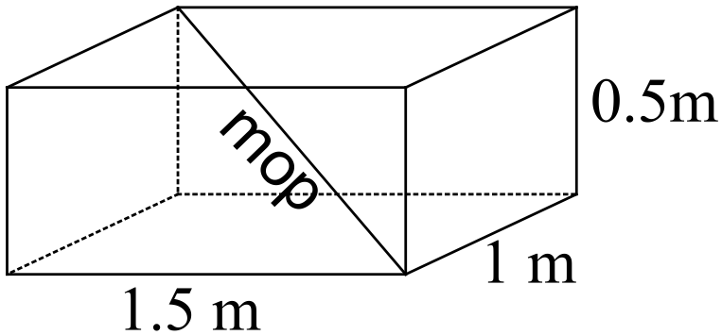(c)
Yes, the 1.7 m mop will fit in the boot.

(d)

(e) (i)
(ii) Weight depends on volume.

Question 13 (21 marks)
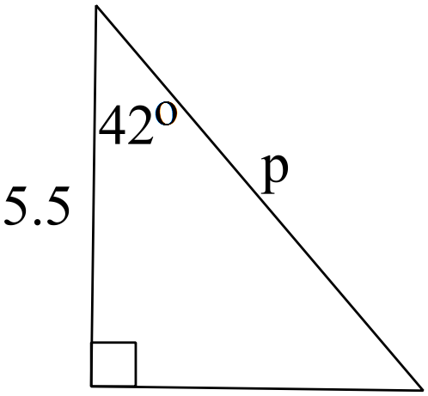(a) (i)

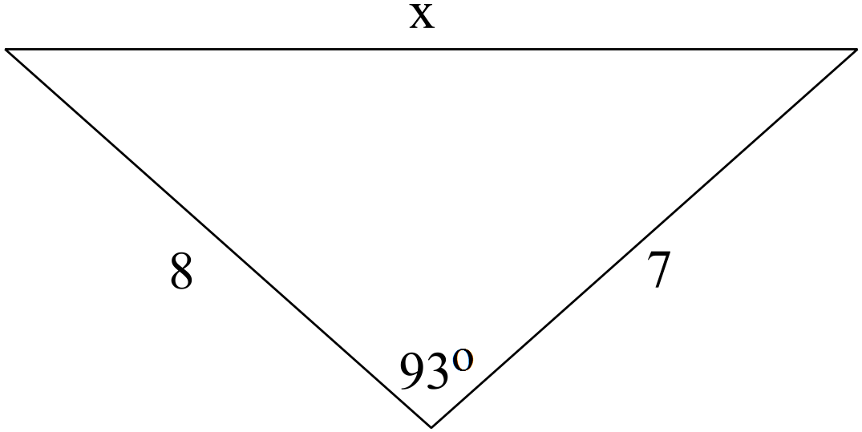
(ii)

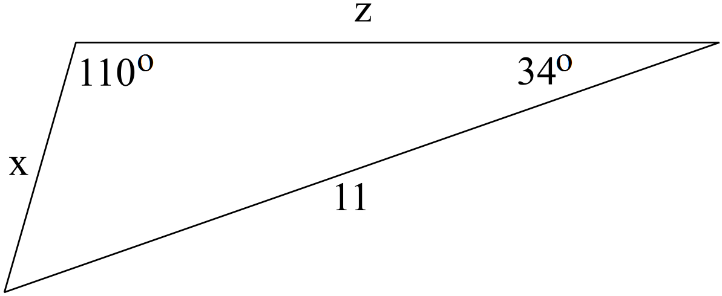

(iii)

(b) (i)
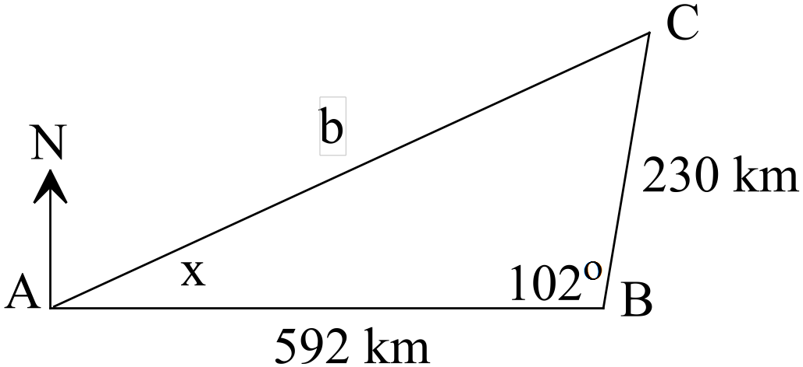

(ii)

Ken had to fly 678 km back to Perth

(iii)

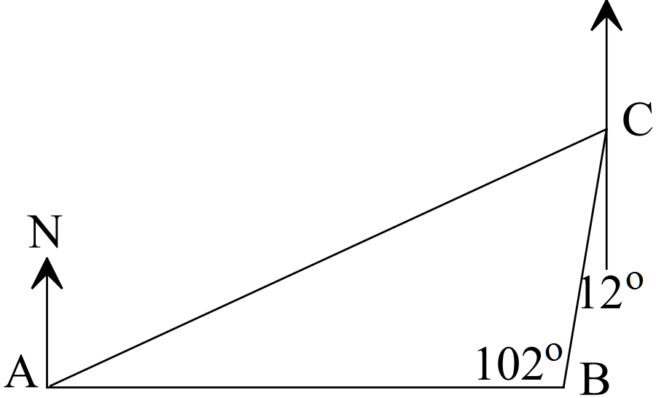

The direction is

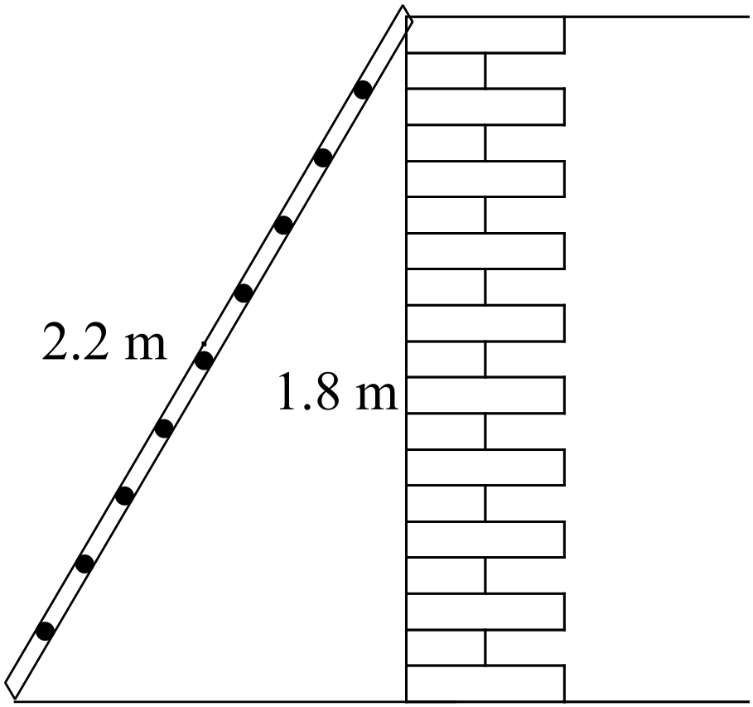(c) (i)

(ii)

Question 14 (5 marks)
Let x = cost of Big Mac
Let y = cost of can of coke
3x + 4y = 22.43 x 2
2x + 5y = 19.62 x -3

6x + 8y = 44.86
-6x - 15y = -58.86
-7y=-14
y = 2
2x + 10 = 19.62
2x = 9.62
x = 4.81
Therefore a Big Mac costs $4.81 and a can of coke costs $2.
Question 15 (6 marks)

Question 16 (15 marks)
(a) (i)
(ii)
(iii)
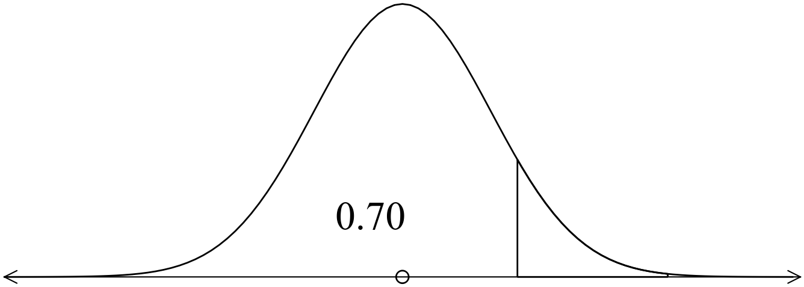 (iv)

(b) (i) English

Mathematics

Damon did relatively better as he was 1.2 standard deviations above the mean
whereas Jenny was 0.5 standard deviations above the mean.

(ii) English
Mathematics

He did better in Maths.

End of solutions

